Date : 23/1/2026
9. Create a Snapshot of a VM and Test it by loading the Previous Version/Cloned VM using a virtual box.

AIM
To create a snapshot of a virtual machine and restore (load) the previous version of the virtual machine using Oracle VirtualBox.

SOFTWARE REQUIREMENTS
- Oracle VM VirtualBox (Latest Version)
- Operating System: Windows 10 / Windows 11
- Virtual Machine: Ubuntu

PROCEDURE
- Open Oracle VM VirtualBox from the Start menu.
- Select the required Virtual Machine from the list.
- Click on the Snapshots option on the right side.
- Click on Take Snapshot.
- Enter a Snapshot Name (example: Snapshot1).
- Click OK to create the snapshot.
- Start the virtual machine and make some changes (for testing purpose).
- Shut down the virtual machine.
- Again go to the Snapshots section.
- Select the previously created snapshot.
- Click on Restore.
- Click Restore again to confirm.
- Start the virtual machine.
- The system loads the previous saved state successfully.

Output :

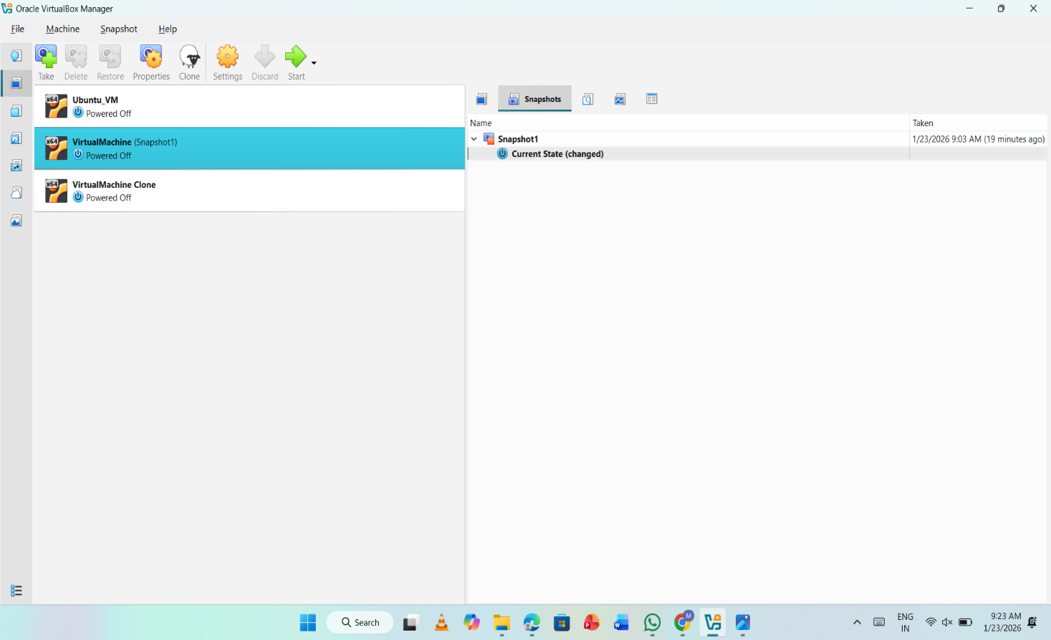

RESULT
The snapshot of the virtual machine was successfully created and the previous version was restored using Oracle VirtualBox.

